**Al Enabled Car Parking Using Open CV**

**Submitted by**

**Team Leader: - Lodagala Teja (SBAP0004605)**

**Team Members: - Ratnala Manasa (SBAP0004616)**

**Tanuja Oleti (SBAP0004622)**

**Vanapalli Priyanka (SBAP0004628)**

**Bachu Laxmi Narasimha Sathya Abhishek (SBAP0004538)**

**Project Name: - Al Enabled Car Parking using OpenCV.**

**Al Enabled Car Parking Using Open CV**

Car parking is a common problem faced by drivers in busy urban areas. For example, imagine you are driving to a shopping mall during peak hours. As you approach the mall, you notice that the parking lot is full, and several other cars are circling around looking for available spots.

You join the queue of cars, hoping to find an available spot soon. However, as time passes, you realize that the parking lot is overcrowded, and it's becoming increasingly difficult to find a spot. You start to feel frustrated and anxious, knowing that you might be late for your appointment or miss out on a great shopping opportunity.

AI-enabled car parking using OpenCV is a computer vision-based project that aims to automate the parking process. The project involves developing an intelligent system that can identify empty parking spaces and gives the count of available parking spots.

The system uses a camera and OpenCV (Open-Source Computer Vision) library to capture live video footage of the parking lot.

# **Architecture:**

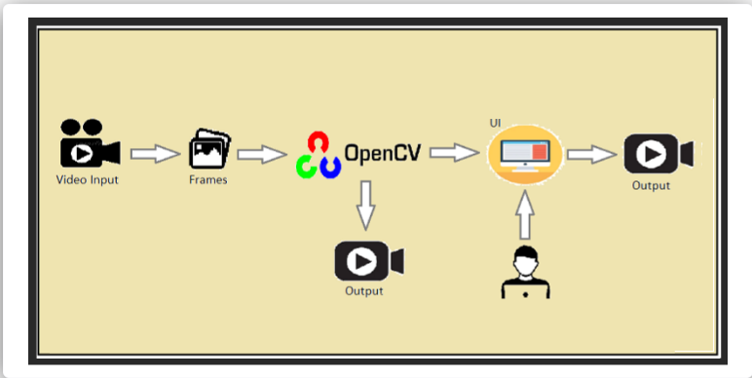

**ABSTRACT**

The problem of finding an appropriate parking space is a challenging one, particularly in large cities. With the increase in car ownership, parking spaces have become scarce. The growing demand for these spots coupled with limited availability has led to imbalances between supply and demand. A lack of adequate parking management systems has resulted in many streets being littered with illegally parked cars. A scalable, reliable, and efficient parking management system is needed to combat this problem. Deep learning-based computer vision techniques have emerged as promising solutions for such problems. These technologies have had a huge impact on the field of image recognition and processing. They also present great potential for further applications in the area of vehicle tracking. Hence, they can be used to detect parking spots. A densely packed city center can be an unbearable place to park your car. Finding parking spaces can prove frustrating if you're not careful. Automatic smart parking systems promise to ease the burden of finding a spot in busy areas. To help drivers find a parking spot, we have developed a vision-based smartparking framework. First, we divided the parking lot into blocks and categorized each block to determine whether it was occupied or empty. Then we sent information about the availability of free or reserved parking to motorists on their smartphones. Our system demonstrates superior performance compared to commercially available solutions because it offers higher accuracy.

**Keywords— parking management; automatic parking; slot recognition; parking space detection; machine learning**

**INTRODUCTION**

Car parking is a common problem faced by drivers in busy urban areas. For example, imagine you are driving to a shopping mall during peak hours. As you approach the mall, you notice that the parking lot is full, and several other cars are circling around looking for available spots.

You join the queue of cars, hoping to find an available spot soon. However, as time passes, you realize that the parking lot is overcrowded, and it's becoming increasingly difficult to find a spot. You start to feel frustrated and anxious, knowing that you might be late for your appointment or miss out on a great shopping opportunity.

AI-enabled car parking using OpenCV is a computer vision-based project that aims to automate the parking process. The project involves developing an intelligent system that can identify empty parking spaces and gives the count of available parking spots.

The system uses a camera and OpenCV (Open-Source Computer Vision) library to capture live video footage of the parking lot.

Most parking lots today are still managed by hand. There is no automated monitoring system in place to keep track of how much capacity each parking place contains. In order to find an empty spot, drivers often have to make a circuitous trip through the parking lot. Where there are more people than parking spots, such problems are especially common near hospitals, malls, schools, and other large gathering places.

The process of finding a free parking space can take a lot of time and involve driving around in circles. These days, parking spots are often occupied so badly that they’re almost unusable. Poorly managed parking areas lead to inefficient utilization of the parking spaces. This causes a lot of traffic jams near the parking areas.

We propose a new method to improve the efficiency of parking lots by counting how much space is left in each parking zone and displaying that information to drivers via a smartphone app. We employ a camera to photograph the parking lot and use image processing approaches to determine if any vehicles are parked in each section. Whenever a vehicle moves into or out of a particular parking zone, the status of the whole lot changes.

**LITERATURE SURVEY**

In this paper, for an autonomous vehicle parking system, we have created and implemented a framework. The experimental results demonstrated the suggested system's ability to provide accurate data.

The issue of parking in crowded regions has been addressed using a variety of strategies and forms. An approach for counting the cars at the checkpoint from which the variety of open parking spots can be counted was once proposed via Ming- Yee Chiu et al.

Induction loop sensors are positioned below the road surface to elevate out the counting. Although the usage of sensors was once much less highly priced, they aren't fluently told by environmental factors, and they reliably detect, their installation was challenging and resulted in road damage. In the event of a problem, maintenance was extremely gruelling.

Grounded on vision- based techniques, various categories of discovery styles are described. The entire parking lot that's open for parking can be analysed by the camera using vision- grounded ways; the facts is also analysed, and the output will specify the unique quantity and regions of the open parking spaces. According to Zhang Bin et al. vision- grounded parking spot detection techniques are relatively simple to set up, inexpensive, and the detector can be quickly modified to meet needs. also, the information gleaned from photographs is quite rich. The precision of the vision approach is severely reliant on the camera's position.

**METHODOLOGY**

Videos were recorded using a camera that was ten feet above the parking lot. To ameliorate the system's ability to recognise objects, video footage was collected under various environmental and temporal situations. Frames are used to segment video. also, to reduce computational complexity, a key frame is uprooted from each segment and subjected to additional processing. Key frame subtraction is used to estimate the motion of the toy auto when it enters or exits the parking lot from the parking arena.

At first, there were no parking lanes in the parking lot. The user must manually enter the location of the intended parking spot and the car. The system automatically creates virtual parking spaces while taking the size of the vehicle into consideration. In our training model, the number of parking spaces is limited to fourteen. Each parking lot has a different numeric label, ranging from 1- 4.

Our system will check to see if there are any cars in each block after the parking area has been partitioned into virtual blocks.

Inverse binary is used to take out the car as the area of past time ROI after applying a binary filter to the image. Calculating the connected region's value in ROI and designating a parking space as reserved when the threshold value exceeds eighty. The count of unreserved sections will be displayed to drivers in green, while the number of reserved sections will be displayed in red.

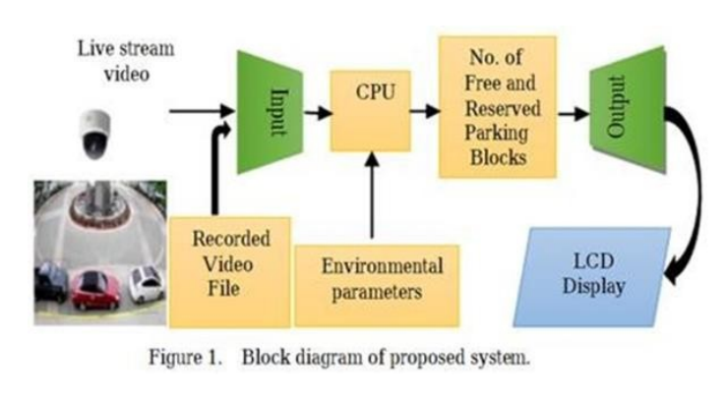

**Labelling of a detection position is initial step. Labelled scenes include:**

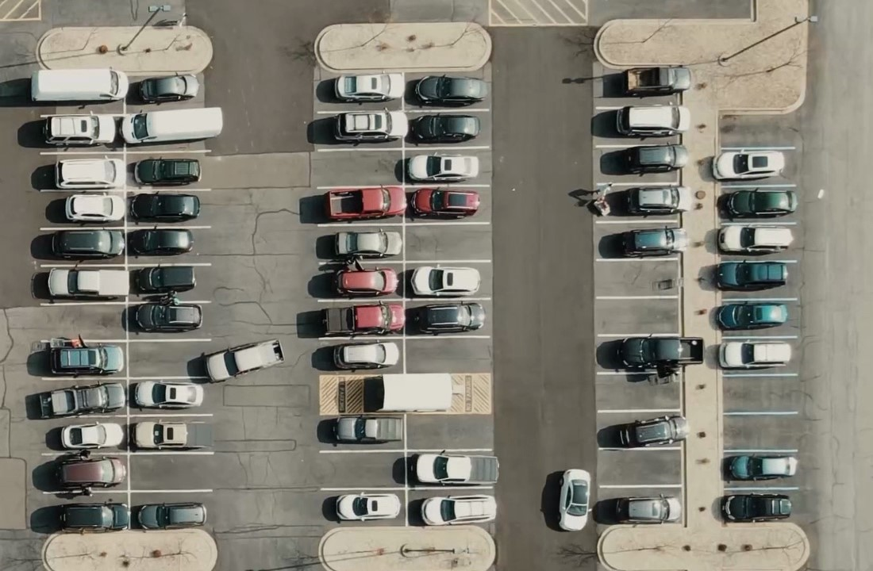

**PLATFORMS USED**

Python is used for the project's execution. A compiler is used, PyCharm. The project is carried out using the following libraries.

1. Open CV- python Open CV, a sizable open- source library for computer vision, machine erudition, and image processing, currently plays a significant part in real- time operation, which is crucial in modern systems. It can be used to process pictures and pictures so that people can fete goods, people's faces, and even human handwriting. The Open CV array structure can be reclaimed by Python for figure out when it's coupled with a variety of libraries, cognate as Num Py. We use vector space and implement fine activities to the aspects of a visual pattern to identify it.

2. Spot Pickle is mostly used in Python to serialise and nonsequential Python object formats. To place it different way, it’s the procedure about converting a Python object into a byte run so that it can be saved in a column or memory, have its state preserved across sessions, or be used to transfer data over a network. By using the pickled byte stream and besides un pickling it, the original object hierarchy can be recreated. Object serialisation in Javaor.Net is correspondent to this entire process.

3.CV zone: This computer vision package facilitates the implementation of AI and image processing operations. It primarily makes use of the OpenCV and Media pipe libraries.

4. NumPy: For the Python programming language, NumPy isa library that adds support for largish, multi-layered arrays and matrices. It additionally affords a big count of high-stage mathematical features to work with these arrays.

5. cv2 library OpenCV has a function called cv2 that can read tape recording (). Pass 0 in the function parameter allows us to penetrate our webcam. The RTSP URL can be dispatched as a

6. PyCharm or other IDE (PyCharm is recommended) PyCharm is a specialised Python Integrated Development Environment (IDE) that gives a vast range of crucial equipment for Python developers.

These equipment’s are tightly built in to create a satisfactory terrain for productive Python, web, and statistics knowledge development.

**DESIGN AND IMPLEMENTATION**

The primary route-way of the proposed algorithm for parking space discovery are.

1. The parking lot will be live- streamed by the camera to the system.

2. When a horseless carriage pulls into or out of the parking space, filmmaking are taken.

3. Grayscale images are created by converting RGB images.

4. Make a adjustments Choosing the parking lot's equals first is a good idea. This will remove any unnecessary white space from the image other than the parking lot.

• Next, decide where the single parking space's parallels are. As a result, the parking lot will be divided into spaces of cognate size.

5. In order to turn the parking lot into black and the auto into white, each block is first converted from grayscale to double and then to inverse binary.

6.To determine if a block contains a car or not, a threshold value is computed for each block. Blocks are free and available for parking if their value is less than a threshold value, and they're occupied if their worth exceeds the threshold.

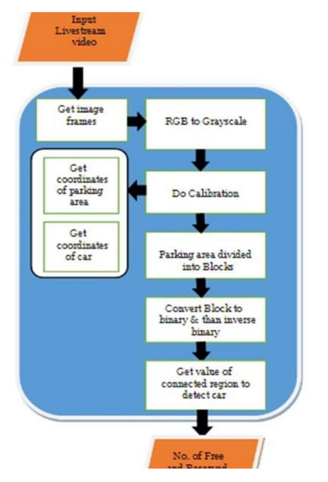

**Pre-Requisites**

1. To complete this project, you must have the following software versions and packages.   
   To make a responsive Python script you must require the following packages.

* PyCharm (Download: https://www.jetbrains.com/pycharm/ )
* Python 3.7.0 (Download: https://www.python.org/downloads/release/python-370/ )
* NumPy
* Cv zone

Flask:

* Web framework used for building web applications.
* Flask Basics: [Click here](https://www.youtube.com/watch?v=lj4I_CvBnt0)

If you are using anaconda navigator, follow the below steps to download the required packages:

* Open anaconda prompt.
* Type "pip install OpenCV-python” and click enter.
* Type "pip install cv zone” and click enter.
* Type “pip install Flask” and click enter.

If you are using PyCharm IDE, you can install the packages through the command prompt and follow the same syntax as above.

Project Flow

* Data Collection
  + Download the dataset.
* ROI (Region of interest)
  + Create python file.
  + Import required libraries.
  + Define ROI width and height.
  + Select and deselect ROI.
  + Denote ROI with BBOX
* Video Processing and object detection
  + Import required libraries.
  + Reading input and loading the ROI file
  + Checking for parking space
  + Looping the video
  + Frame processing and empty parking slot counters
* IBM Database Connection
  + Create IBM DB2 service and table.
* Application building
  + Build HTML
  + Build Python script for Flask.

### Project Structure

Create a project folder that contains files as shown below:

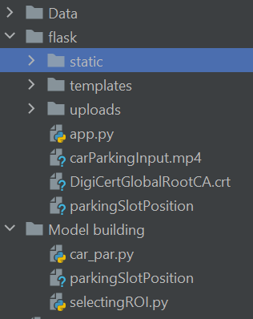

* The Dataset folder contains the video and image file.
* For building a Flask Application we need HTML pages stored in the templates folder, CSS for styling the pages stored in the static folder, and a python script app.py for server-side scripting.
* Model Building folder consists of car.py & selectingROI.py python script.

**Download The Dataset**

Click the below link to download the dataset for AI-Enabled Car Parking using OpenCV.

Link - <https://drive.google.com/drive/folders/13vNq4XZLV15uxxXrVkj33Jr7VflrhKWr?usp=share_link>

**Create A Python File**

Create a python file in the directory and name it ‘selectingROI.py’. This Python file is used for creating ROI and deleting ROI.

**Importing The Required Packages**

Open cv: OpenCV is a great tool for image processing and performing computer vision tasks. It is an open-source library that can be used to perform tasks like face detection, objection tracking, landmark detection, and much more. It supports multiple languages including Python, java, C++.

Pickle: The pickle library in Python is used for the serialization and de-serialization of Python objects. Serialization is the process of converting a Python object into a stream of bytes that can be stored in a file or sent over a network. De-serialization is the process of converting the serialized data back into a Python object.

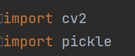

### Define ROI Width and Height

* Calculating the ROI width and height (manually width and height are calculated and given as 107 & 48).
* An empty file parking Slot Position is created to save all the ROI values. Try and except combo is used.
* In Python, try and except are used for error handling, to catch and handle exceptions that may occur during program execution. The try block is used to enclose the code that may raise an exception, and the except block is used to define what should happen if an exception is raised.

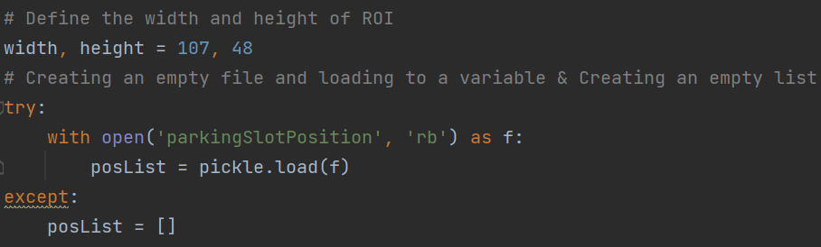

**Select And Deselect ROI**

* A function is defined as mouse Click. As parameters we are passing events (mouse action), x (ROI starting point), y (ROI ending point), flags (Boolean flag), and params (other parameters).
* In 1st if condition: After the left click from the mouse, the starting and ending points will be added to posits by append method.
* In 2nd if condition: If ROI is selected in the unwanted region. Then we can remove that unwanted ROI by right click from the mouse.
* Python objects are converted into a stream of bytes and stored in the parking Slot Position file.

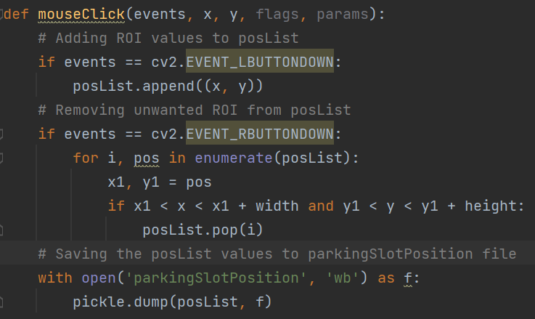

**Denote ROI With BBOX**

* Reading the image with imread() method from cv2.
* All ROIs are saved in posList (refer to activity 4).
* The rectangle is created as BBOX with the starting value (x) and ending value (y) from posList by the rectangle () method. As the parameters give image source, starting value, ending value, (starting value + width, ending value + height), (color), and thickness.
* For displaying the image imshow() method is used.
* setMouseCallback() function is used to perform some action on listening to the event which we have defined in activity 4.

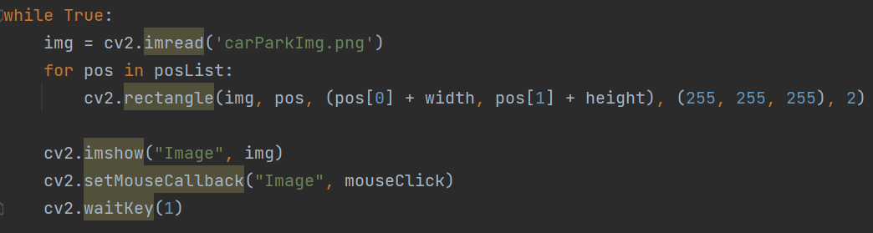

### Video Processing and Object Detection

Create a new Python file to perform video processing, object detection, and counters.

**Application Building**

In this section, we will be building a web application that is integrated to the model we built. A UI is provided for the uses where he must enter the values for predictions. The enter values are given to the saved model and prediction is showcased on the UI.

This section has the following tasks.

* Building HTML Pages
* Building python code

**Building Html Pages**

* For this project, we have created 2 HTML files and saved them in the templates folder. Let’s see what those HTML pages looks like:

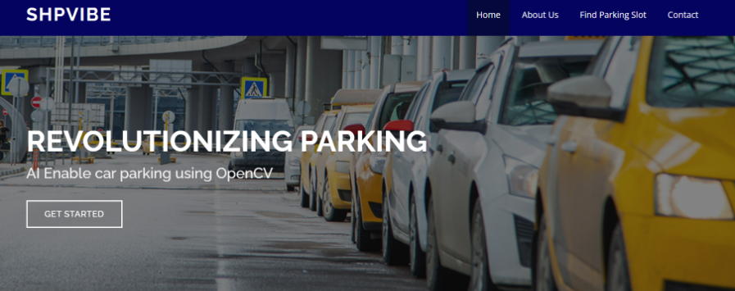

**Build Python Code**

* Import the libraries.

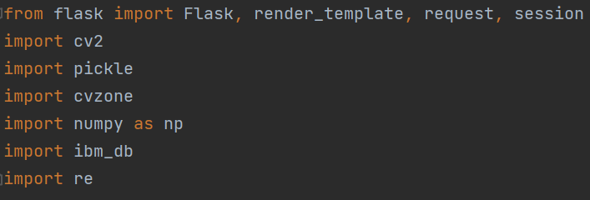

* Importing the Flask module into the project is mandatory. An object of the Flask class is our WSGI application. The Flask constructor takes the name of the current module (__name__) as an argument.

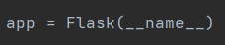

Render HTML page:

* Here we will be using the declared constructor to route to the HTML page that we created earlier. In the above example, the ‘/’ URL is bound with the index.html function. Hence, when the home page of the web server is opened in the browser, the HTML page will be rendered.

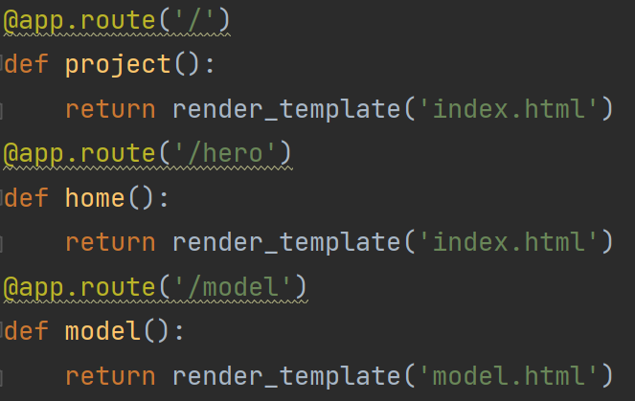

* Create a decorator to route to ‘/predict live’. Go to milestone 3 and copy the entire code and paste it inside the function liv_pred.

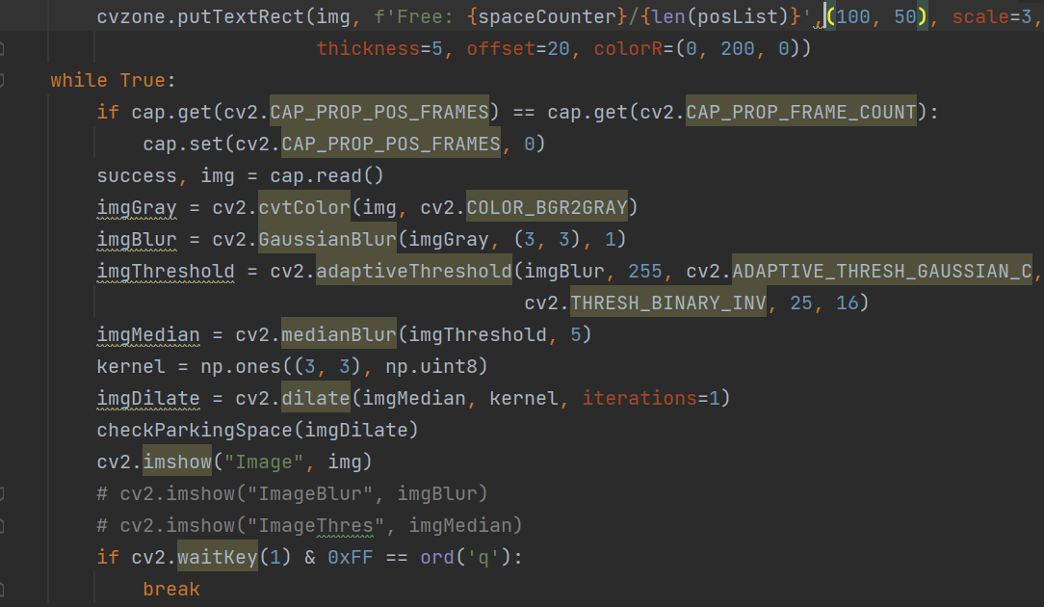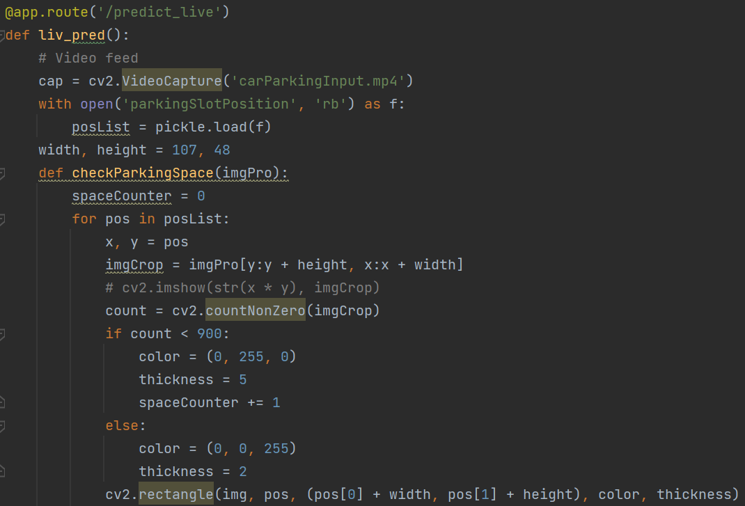

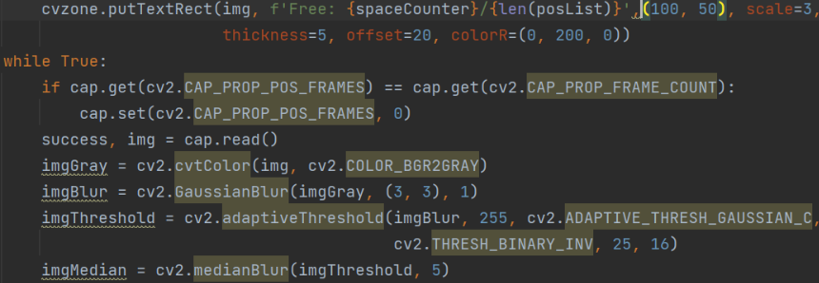

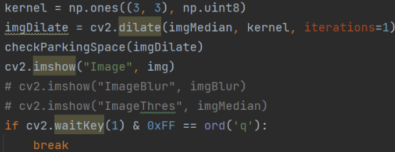

**Run The Application**

* Open the anaconda prompt from the start menu.
* Navigate to the folder where your Python script is.
* Now type the “python app.py” command
* Navigate to the localhost where you can view your web page.
* Click on the predict button from the top right corner, enter the inputs, click on the submit button, and see the result/prediction on the web.

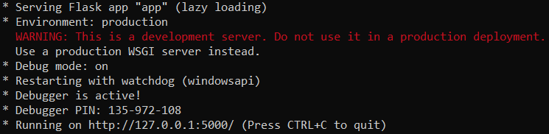

**Output:**

Click on the ‘Click here’ button.

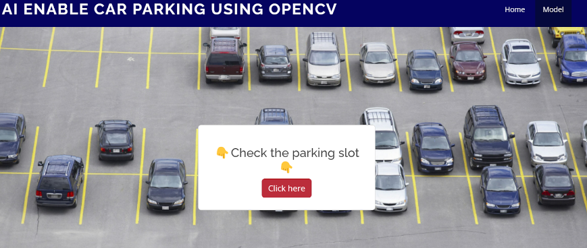

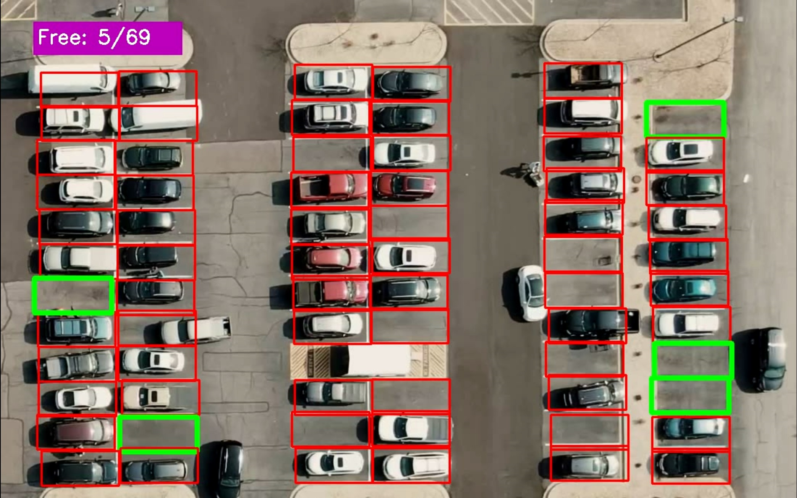

**CONCLUSION**

This study's main beneficence is to perfect the unearthing of open parking spaces in an expenditure to ease parking arena slowdown. The development of machine learnedness and vision- grounded technology has made it possible for motorcars to find open spaces at parking lots using affordable automatic parking systems. unborn studies can concentrate on assigning specific emplacements to customers who have afore registered with an online parking management system.

The precision about the proposal algorithm is inaugurated to be 92. The outcomes demonstrates that, when the captured photos of the parking lot aren`t clear due to low lighting or overlaps, the productivity drops and the exactitude for spotting decreases. It’s noticed that the average performance is 99.5 and is remarkably high as contrasted with other parking lot finding out procedures. The effectiveness of the proposed method in some cases drops down due to the strong darkness. The ultra precision of Get image frames RGB to Gray image Do Calibration Get equals of parking spot Get fellows of car Parking spot divided into Blocks Convert Block to inverse binary Get value of connected locality to determine autos number of free and Reserved Blocks Input Live stream recording 1313 the proposed task additionally relies on the kind of camera utilized for covering the parking lot.

**FUTURE SCOPE**

● Hook up a webcam to a snort Pi and have live parking monitoring at home

● alchemize parking lot video to have overview perspective (for clearer globules)

● It’s effective at resolving parking issues. In addition, it provides automatic billing, as well as eliminating traffic congestion. Utilising a multilevel parking technique, this work can be further developed into a fully automated system.

● The system presents the details of vacant parking areas nearby and reduces the market problems related to illegal parking in the area. It was intended to meet the requirements of controlled parking that offers downhill parking techniques to the authorities.